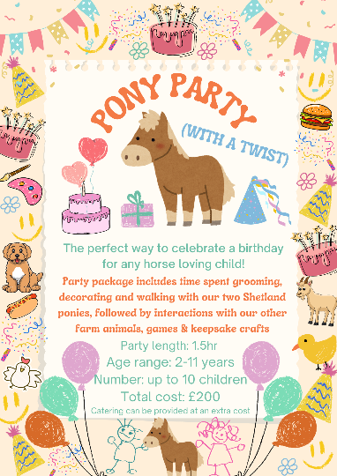
Pony Party
Booking Form
Name of party child |  | Child’s DOB
Organisers Name  (This is the person responsible for payment) |  | Organisers Mobile Number
Organisers Home Address
Organisers Email Address
Number of children attending the party |  | Age range of children
Preferred Party Date |  | Preferred party time
Do any children have allergies/intolerances of any kind? | If yes, please give details:
Do any of the children in attendance have additional needs? | If yes, please give details:

Our pony parties take place on weekends & must be booked at least two weeks in advance of the scheduled party date.

Do you require catering for the party?  (We offer sandwiches and party food for an additional £6 per child) |  |  | YES/NO
Sandwiches  (Please choose bread) | White bread |  | Brown bread |  | Mixed
Fillings  (Please choose preferred fillings)) | Ham |  | Cheese |  | Jam
 | Chocolate Spread |  | Butter? | YES/NO | Crusts on? | YES/NO
Crisps  (Please highlight preference) | Salt & Vinegar | Lightly Salted | Cheese & Onion | Cheese Curls | Cheese Puffs | Mixed
Birthday Tray Cake (£8)  (Please highlight) | YES/NO | Squash  (Please highlight preference) |  | Orange | Blackcurrant | Apple
Additional options:

Deposit:
A £50 deposit is required on booking (non-refundable).
Once we confirm, via email, the date & time of your scheduled party, the deposit must be transferred within 24 hours. If the transfer isn’t made within this timescale, the party date/time will be offered out for re-booking.

Details for deposit & payment purposes:
Company Name | Breathing Space Therapeutic Services CIC
Bank Name | Lloyds Bank (Business Account)
Account Number | 57414168
Sort Code | 77-33-02
Reference | “Pony Party” (include party date)

By signing this form, you are agreeing to our booking terms/conditions and confirming that you have read, understood and agree to the “Pony Party terms, conditions & safety information” two-page document on our website.
Organisers Name
Organisers Signature
Date

